Any Saturday – December | Natchitoches, LA

The Natchitoches Christmas Season is a captivating six week ‘Night of Lights’ celebration that includes over 100 beautifully hand-crafted set pieces with over 300,000 Christmas lights in downtown Natchitoches and on Cane River Lake. Since 1927, Christmas magic takes place throughout this celebration including photos with Santa, 18th century style reenactment, arts and crafts shows, live entertainment, children’s activities, Christmas Tour of Homes, and fireworks every Saturday.

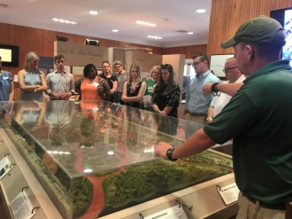
EXPLORE | Fort St. Jean Baptiste State Historic Site
155 rue Jefferson | (318) 357-3101 - Call for Hours & Tour Times
Experience the French Colonial life as you are guided through the fort by costumed interpreters. The full sized replica of Fort St. Jean Baptiste, is located on Cane River Lake (formerly the Red River), a few hundred yards from the original fort site, set up by Louis Antoine Juchereau de St. Denis in 1714. Nearly 2,000 treated pine logs form the palisade and approximately 250,000 board feet of treated lumber went into the construction of the buildings.
https://www.crt.state.la.us/louisiana-state-parks/historic-sites/fort-st-jean-baptiste-state-historic-site/index
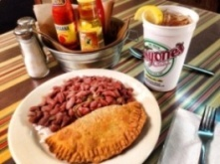
LUNCH/DINNER | Historic District Dining
All historic district restaurants locally owned and operated serving authentic Creole, Cajun and Southern dishes. All restaurants in Louisiana are smoke free. Call for group reservations. For a full listing of restaurants in the historic district please visit Natchitoches.com/dining.

EXPLORE | Cane River Carriage Company and The Venue on Front Street
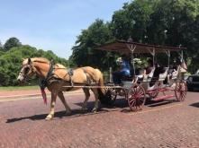
Downtown Natchitoches | Cane River Carriage Company (601) 807-9086 | The Venue on Front Street (318) 228-3385 - Call for Hours & Tour Times
Take a guided tour through the Historic District of Natchitoches on a horse drawn carriage or atop one of the new “horseless” carriages. You’ll see the historic sites of our town as well as the Steel Magnolias filming sites. The carriages are available for weddings and special events. Call for group reservations and tour times.

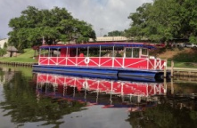
EXPLORE | Cane River Queen River Boat
103 rue Beauport | (318) 663-7787 - Call for Hours & Tour Times
Take a leisurely cruise aboard the Cane River Queen. The red, white, and blue vessel meanders along the tranquil waters of Cane River Lake. Groups/special events welcome. Call for tour times and group reservations.

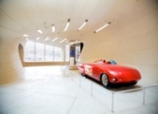
EXPLORE | Louisiana Sports Hall of Fame & Northwest Louisiana History Museum
800 Front St. | (318) 357-2492 - Call for Hours & Tour Times
Discover the dazzling state museum complex in historic downtown Natchitoches. The Louisiana Sports Hall of Fame’s collections celebrate more than 300 sports achievements through exhibits and interactive media. The Northwest Louisiana History Museum journeys through unique cultural traditions from early native-American civilizations to the present. Named Top Global Architecture Project in 2014, the building evokes the region’s natural resources.

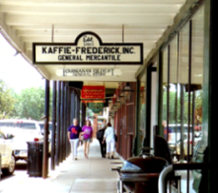
SHOPPING | National Historic Landmark District
At the heart of Natchitoches is the enchanting historic hub showcasing over 300 years of Louisiana French colonial history. The downtown district serves as a shopping and dining paradise. You can find everything you’re looking for including antiques, home décor, books, local art, kitchenware, clothing, souvenirs, tasty treats and much more! Each shop has its own special Southern Charm.

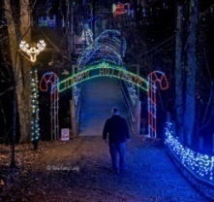
DISCOVER | Christmas in the Park
4343 University Parkway (LA Hwy 6) | (318) 289-9019 - Call for Hours & Tour Times
Stroll through 4 acres of enchanting walkways and over 175,000 LED lights! Twinkling tree forms, candy cane lane, singing Christmas trees, and a 128 ft. lighted footbridge. Open last weekend in November through Christmas Day.
https://www.darkwoodschristmas.com/

DISCOVER | Special Events
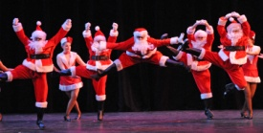
Most Saturdays during the Christmas season feature a special event. Special events during the holiday season range from arts & crafts shows, parades, Christmas home tours, children events, and more. For a list of events during Christmas season, visit https://www.natchitocheschristmas.com/.

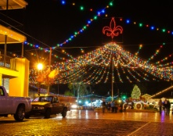
CELEBRATE | Christmas Magic
Enjoy over 300,000 Christmas lights and live entertainment as Christmas comes to life! Take a carriage ride, stroll along Front Street or down on the riverbank, sample local favorites from food vendors, and enjoy the sights and sounds of the season.

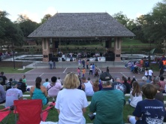
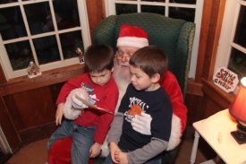
CELEBRATE | Live Entertainment
Enjoy live entertainment on the Riverbank Stage. Experience music genres ranging from Country, Southern Rock, Zydeco, and more during the holiday season. Each Saturday offers a different musical experience.

DISCOVER | Visit with Santa
(318) 352-2746 - Call for Hours & Dates
Visit nightly with Santa on the south end Downtown Riverbank | FREE

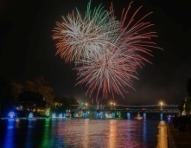
CELEBRATE | Fireworks Show – 7:00pm
Experience a magnificent fireworks show choreographed to holiday music over the riverbank of
Cane River Lake.

For more holiday itineraries from Natchitoches and our partners, visit https://holidaytrailoflights.com/

