Any Weekday – Christmas Season | Natchitoches, LA

The Natchitoches Christmas Season is a captivating six week ‘Night of Lights’ celebration that includes over 100 beautifully hand-crafted set pieces with over 300,000 Christmas lights in downtown Natchitoches and on Cane River Lake. Since 1927, Christmas magic takes place throughout this celebration including photos with Santa, 18th century style reenactment, arts and crafts shows, live entertainment, children’s activities, Christmas Tour of Homes, and fireworks every Saturday.
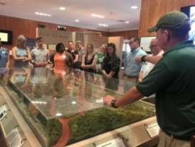
EXPLORE | Fort St. Jean Baptiste State Historic Site
155 rue Jefferson | (318) 357-3101 - Call for Hours & Tour Times
Experience the French Colonial life as you are guided through the fort by costumed interpreters. The full sized replica of Fort St. Jean Baptiste is located on Cane River Lake (formerly the Red River), a few hundred yards from the original fort site set up by Louis Antoine Juchereau de St. Denis in 1714. Nearly 2,000 treated pine logs form the palisade and approximately 250,000 board feet of treated lumber went into the construction of the buildings.
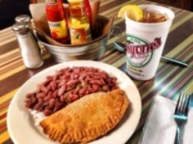
https://www.crt.state.la.us/louisiana-state-parks/historic-sites/fort-st-jean-baptiste-state-historic-site/index

LUNCH | Historic District Dining
All historic district restaurants are locally owned and operated serving authentic Creole, Cajun and Southern dishes. All restaurants in Louisiana are smoke free. Call for group reservations.

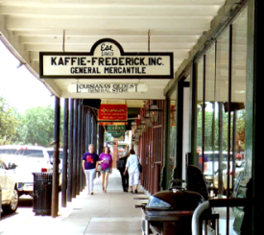
SHOPPING | National Historic Landmark District
At the heart of Natchitoches is the enchanting historic hub showcasing over 300 years of Louisiana French colonial history. The downtown district serves as a shopping and dining paradise. You can find everything you’re looking for including antiques, home décor, books, local art, kitchenware, clothing, souvenirs, tasty treats and much more! Each shop has its own special Southern charm.

TAKE A TOUR | Cane River National Heritage Area Walking Tour
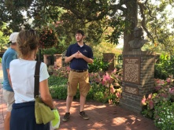
Tour starts at 780 Front St. | (318) 356-5555 - Call for Hours & Tour Times
Discover why Natchitoches has been a destination for travelers since 1714 – take a FREE guided walking tour of Natchitoches’ National Historic Landmark District. The tour is designed to provide a general overview of Natchitoches and the Cane River Region, covering the following topics: the Cane River region prior to European contact, the French & Spanish colonial period, antebellum plantation culture and period, reconstruction and tenant farming, architectural history, and Creole and Catholic culture, history, and customs. This tour is family-friendly and meant to engage all ages.
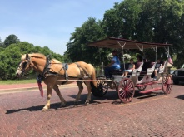
EXPLORE | Cane River Carriage Company and The Venue on Front Street
Downtown Natchitoches | Cane River Carriage Company (601) 807-9086 | The Venue on Front Street (318) 228-3385 - Call for Hours & Tour Times
Take a guided tour through the Historic District of Natchitoches on a horse drawn carriage or atop one of the new “horseless” carriages. You’ll see the historic sites of our town as well as the Steel Magnolias filming sites. The carriages are available for weddings and special events. Call for group reservations and tour times.

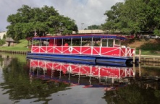
DISCOVER | Cane River Queen Riverboat
(318) 663-7787 - Call for Hours & Tour Times
Take a leisurely cruise aboard the Cane River Queen. The red, white, and blue vessel meanders along the tranquil waters of Cane River Lake. Groups/special events welcome.

DISCOVER | Cane River National Heritage Trail

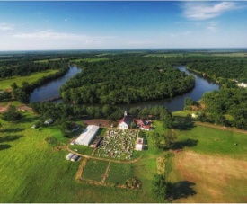
A Louisiana Scenic Byway

Once a primary channel of the Red River, the Cane River is now an oxbow lake bordered by corn and soybean farms, thick stands of sugar cane and pecan orchards. The Cane River National Heritage Trail begins in charming Natchitoches, which many recall as the setting for the film Steel Magnolias. Tracking the river, the trail winds through rich farmland and pretty towns. It ends at Cloutierville, once the home of writer Kate Chopin. Along the way, views include plantation homes, distinctive Creole architecture and historic landmarks, along with graceful Southern magnolias, crepe myrtles, chinaberry trees and live oaks that flourish on the river’s red-soil banks.

www.canerivernha.org

EXPLORE | Melrose on the Cane
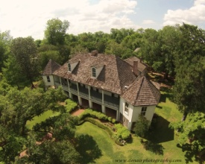
3533 Hwy 119 Melrose, LA 71452 | (318) 379-0055 – Call for Hours & Tour Times
Discover the two-hundred year history of beautiful Melrose on the Cane founded in 1796 by Louis Metoyer, one of the ten Franco-African children of slave, Marie Therese CoinCoin, and Claude Thomas Pierre Metoyer, a merchant at Ft St. Jean Baptiste. Their descendants began the unique Isle Brevelle community whose rich culture continues today. Explore the wonders of the early 20th century artists retreat founded by Carmelite “Cammie” Garrett Henry and follow the discovery of Clementine Hunter, one-time Melrose cook, as she emerged to become a celebrated Louisiana folk artist. See her acclaimed murals in their home, the African House, designated a “National Treasure” in 2015 by the National Trust for Historic Preservation. Every spring, Melrose Plantation hosts Louisiana’s longest-running arts and crafts festival. Vis https://melroseonthecane.com/.

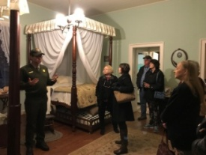
EXPLORE | Cane River Creole National Historical Park: Oakland Plantation
4386 Hwy 494 Natchez, LA 71456 | 318-352-0383, ext. 316 – Call for Hours & Tour Times
Plantations resembled small towns with numerous buildings. Oakland has 17 original outbuildings still standing including two pigeonniers, an overseer’s house, log corn crib, carriage house, cook’s cabin, mule barn (originally a smokehouse), carpenter shop and cabins. The historic property is a National Bicentennial Farm, only one of two such Farms west of the Mississippi River, both of which are located in Natchitoches Parish. The National Park Service acquired Oakland in the late 1990s as part of Cane River Creole National Historical Park.
*Free Admission
www.nps.gov/cari/index.htm

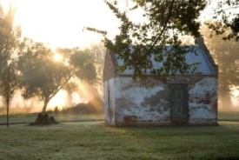
EXPLORE | Cane River Creole National Historical Park: Magnolia Plantation
5549 Hwy. 119, Derry, LA 71416 | 318-352-0383, ext. 316 – Call for Hours & Tour Times
Prior to the Civil War, Magnolia was one of the largest plantations in Natchitoches Parish. Original outbuildings include a blacksmith shop, plantation store, slave hospital that at various times housed the owners and overseer, eight brick cabins, and gin barn. The gin barn houses a wood screw cotton press, the last such press remaining in its original site in the United States.
*Free Admission
www.nps.gov/cari/index.htm
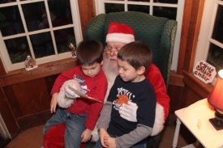

DISCOVER | Visit with Santa
(318) 352-2746 - Call for Hours & Dates
Visit nightly with Santa on the south end Downtown Riverbank | FREE

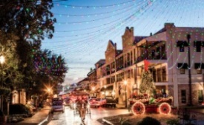
CELEBRATE | Christmas Magic
Enjoy over 300,000 Christmas lights and live entertainment as Christmas come to life! Take a carriage ride, stroll along Front Street or down on the riverbank, sample local favorites from food vendors and enjoy sights and sounds of the season.

For more holiday itineraries from Natchitoches and our partners, visit https://holidaytrailoflights.com/

