Cane River National Heritage Trail Tour | Natchitoches, LA

Cane River National Heritage Area is a largely rural, agricultural landscape known for its historic plantations, Creole architecture and multicultural legacy. Historically, this 116,000 acre region lies at the intersection of French and Spanish colonial realms. Today, it is home to a unique blend of cultures, including French, Spanish, African, American Indian and Creole.

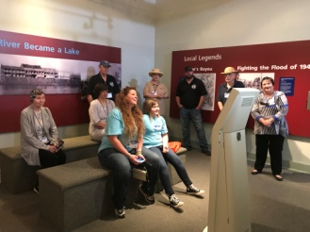
EXPLORE | Grand Ecore Visitor Center
106 Tauzin Island Road | (318) 356-5555 – Call for Hours & Tour Times
Discover exhibits educating and informing the public about the Water and the Corps of Engineers’ role in development, preservation, and enhancement of the water resources in the region; as well as the geology, paleontology, and Native American cultures of the region. It is also known for the role it played during the Civil War as a Confederate outpost guarding the Red River from Union advancement.
https://www.canerivernha.org/grand-ecore-visitor-center

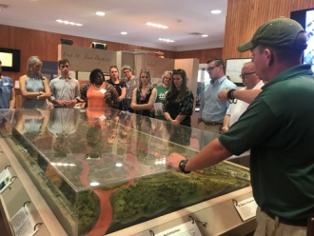
EXPLORE | Fort St. Jean Baptiste State Historic Site
155 Rue Jefferson, Natchitoches | 318-357-3101 – Call for Hours & Tour Times
Experience the French Colonial life as you are guided through the fort by costumed interpreters. The full sized replica of Fort St. Jean Baptiste is located on Cane River Lake (formerly the Red River), a few hundred yards from the original fort site set up by Louis Antoine Juchereau de St. Denis in 1714. Nearly 2,000 treated pine logs form the palisade and approximately 250,000 board feet of treated lumber went into the construction of the buildings.
https://www.crt.state.la.us/louisiana-state-parks/historic-sites/fort-st-jean-baptiste-state-historic-site/index

EXPLORE | Cane River Creole National Historical Park: Oakland Plantation
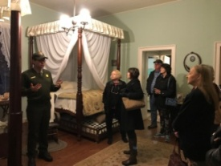
4386 Hwy 494 Natchez, LA 71456 | (318) 352-0383 ext. 316 – Call for Hours & Tour Times
Plantations resembled small towns with numerous buildings. Oakland has 17 original outbuildings still standing including two pigeonniers, an overseer’s house, log corn crib, carriage house, cook’s cabin, mule barn (originally a smokehouse), carpenter shop and cabins. The historic property is a National Bicentennial Farm, only one of two such Farms west of the Mississippi River, both of which are located in Natchitoches Parish. The National Park Service acquired Oakland in the late 1990s as part of Cane River Creole National Historical Park.
*Free Admission
www.nps.gov/cari/index.htm
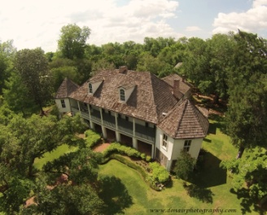
EXPLORE | Melrose on the Cane
3533 Hwy 119 Melrose, LA 71452 | (318) 379-0055 – Call for Hours & Tour Times
Discover the two-hundred year history of beautiful Melrose Plantation founded in 1796 by Louis Metoyer, one of the ten Franco-African children of slave, Marie Therese CoinCoin and Claude Thomas Pierre Metoyer, a merchant at Ft St. Jean Baptiste. Their descendants began the unique Isle Brevelle community whose rich culture continues today. Explore the wonders of the early 20th century artists’ retreat founded by Carmelite “Cammie” Garrett Henry and follow the discovery of Clementine Hunter, one-time Melrose cook, as she emerged to become a celebrated Louisiana folk artist. See her acclaimed murals in their home, the African House, designated a “National Treasure” in 2015 by the National Trust for Historic Preservation.
Every spring, Melrose Plantation hosts Louisiana’s longest-running arts and crafts festival. https://melroseonthecane.com/

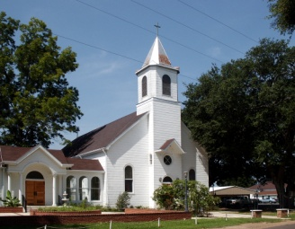
EXPLORE | St. Augustine Catholic Church & Cemetery
2250 Hwy 484 Melrose, LA 71452 | (318) 379-2521 – Call for Hours & Tour Times
A historic Roman Catholic Church and cemetery, it is the cultural center of Cane River's historic Créole community. Established as a mission church in 1829 by the freed slave Nicolas Augustin Metoyer, St. Augustine is celebrated as the first church built by and for free people of color in Louisiana. The church and cemetery are on the National Register of Historic Places. Because of its significance to Catholic and Créole history, St. Augustine is also listed on the Louisiana African American Heritage Trail. The church was the filming site for the wedding scene in the movie Steel Magnolias and is open to the public.

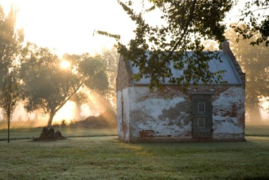
EXPLORE | Cane River Creole National Historical Park: Magnolia Plantation
5549 Hwy. 119, Derry, LA 71416 | 318-352-0383, ext. 316 – Call for Hours & Tour Times
Prior to the Civil War Magnolia was one of the largest plantations in Natchitoches Parish. Original outbuildings include a blacksmith shop, plantation store, slave hospital that at various times housed the owners and overseer, eight brick cabins, and gin barn. The gin barn houses a wood screw cotton press, the last such press remaining in its original site in the United States.
*Free Admission
www.nps.gov/cari/index.htm

EXPLORE | Los Adaes State Historic Site
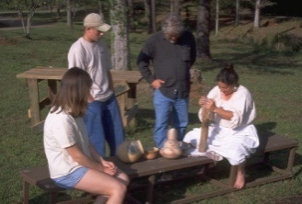
6354 Hwy 485 Robeline, LA 71449 | (318) 356-5555 – Call for Hours & Tour Times
Los Adaes, the symbol of New Spain in Louisiana, was once the capital of Texas and the scene of a unique cooperation among the French, the Spanish and the indigenous Native Americans. An area rich in archaeological finds, it thrives today as one of Louisiana's most intriguing state historic sites. Established in 1719 in response to a French attack on Mission San Miguel, the Presidio Nuestra Señora del Pilar de Los Adaes (Fort of Our Lady of Pilar at the Adaes) was built to counter any further French intrusion into Spanish territory. Los Adaes was designated as the capital of the province of Texas in 1729, becoming the official residence of the governor. It remained the capital until 1772 when it was closed and the inhabitants moved to San Antonio.
https://www.canerivernha.org/fort-st-jean-baptiste-los-adaes-state-historic-sites

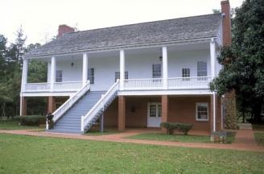
EXPLORE | Fort Jesup State Historic Site
32 Geoghagan Rd. Many, LA 71449 | (318) 357-3101 – Call for Hours & Tour Times
Fort Jesup, a state historic site, was built in 1822, 22 miles west of Natchitoches, to protect the United States border with Spain and to return order to the Neutral Strip. The Neutral Strip was created after the 1803 Louisiana Purchase, from which arose a disagreement about the location of the border between the US and Spanish territories. Tours by appointment only, call Fort St. Jean Baptiste State Historic Site, (318) 357-3101.
For more information and itineraries on the Neutral Strip (No Man’s Land) visit https://www.visitnomansland.com/.

