El Camino Real | Natchitoches, LA

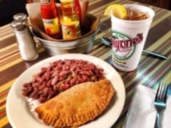
LUNCH/DINNER | Historic District Dining
All historic district restaurants are locally owned and operated serving authentic Creole, Cajun and Southern dishes. All restaurants in Louisiana are smoke free. Call for group reservations. For a full listing of restaurants in the historic district please visit https://natchitoches.com/dining.

EXPLORE | Los Adaes State Historic Site
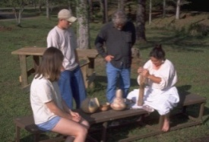
6354 Hwy 485 Robeline, LA 71449 | (318) 356-5555 – Call for Hours & Tour Times
Los Adaes, the symbol of New Spain in Louisiana, was once the capital of Texas and the scene of a unique cooperation among the French, the Spanish and the indigenous Native Americans. An area rich in archaeological finds, it thrives today as one of Louisiana's most intriguing state historic sites. Established in 1719 in response to a French attack on Mission San Miguel, the Presidio Nuestra Señora del Pilar de Los Adaes (Fort of Our Lady of Pilar at the Adaes) was built to counter any further French intrusion into Spanish territory. Los Adaes was designated as the capital of the province of Texas in 1729, becoming the official residence of the governor. It remained the capital until 1772 when it was closed and the inhabitants moved to San Antonio.
https://www.crt.state.la.us/louisiana-state-parks/historic-sites/fort-st-jean-baptiste-state-historic-site/index

EXPLORE | Fort St. Jean Baptiste State Historic Site
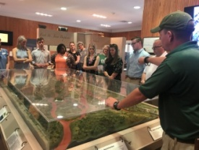
155 Rue Jefferson, Natchitoches | 318-357-3101 – Call for Hours & Tour Times
Experience the French Colonial life as you are guided through the fort by costumed interpreters. The full sized replica of Fort St. Jean Baptiste is located on Cane River Lake (formerly the Red River), a few hundred yards from the original fort site set up by Louis Antoine Juchereau de St. Denis in 1714. Nearly 2,000 treated pine logs form the palisade and approximately 250,000 board feet of treated lumber went into the construction of the buildings.
https://www.crt.state.la.us/louisiana-state-parks/historic-sites/fort-st-jean-baptiste-state-historic-site/index

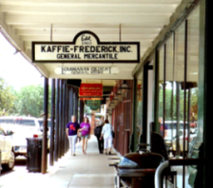

SHOPPING | National Landmark Historic District
At the heart of Natchitoches is the enchanting historic hub showcasing over 300 years of Louisiana French colonial history. The downtown district serves as a shopping and dining paradise. You can find everything you’re looking for including antiques, home décor, books, local art, kitchenware, clothing, souvenirs, tasty treats and much more! Each shop has its own special Southern charm.

EXPLORE | Louisiana Sports Hall of Fame & Northwest Louisiana History Museum
800 Front St. | (318) 357-2492 – Call for Hours & Tour Times
Discover the dazzling state museum complex in historic downtown Natchitoches. The Louisiana Sports Hall of Fame’s collections celebrate more than 300 sports achievements through exhibits and interactive media. The Northwest Louisiana History Museum journeys through unique cultural traditions from early Native American civilizations to the present. Named Top Global Architecture Project in 2014, the building evokes the region’s natural resources.

