Gators, Gardens & Parks | Natchitoches, LA
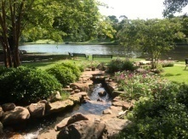
EXPLORE | Beau Jardin Garden & Water Feature & Roque House Park
781 Front St. | (318) 352-2746
Explore the garden area and various water features on the downtown riverbank overlooking Cane River Lake. This intimate setting is perfect for weddings, family photos, picnics, and small outdoor meetings.

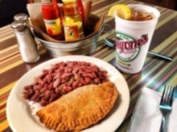
LUNCH/DINNER | Historic District Dining
All historic district restaurants are locally owned and operated serving authentic Creole, Cajun and Southern dishes. All restaurants in Louisiana are smoke free. Call for group reservations. For a full listing of restaurants in the historic district please visit https://natchitoches.com/dining.

DISCOVER | Natchitoches Pocket Parks
All pocket parks are in downtown Natchitoches.

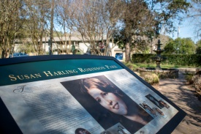
Susan Harling Robinson Memorial Park | Located on the corner of Pine and Cypress
This park was erected to commemorate the life of Susan Harling Robinson. Susan Harling Robinson’s life story is the inspiration behind Steel Magnolias, for both the film and play. The film celebrates strength and indomitable spirit of Southern women. Susan passed away in October of 1985 and treasured the pride of heritage and the beauty one finds in her beloved Natchitoches. The history of Natchitoches is filled with amazing women noted for their strength, courage and purpose. The dedication of this park to Susan adds another name to that illustrious list.

Dr. Mildred H. Bailey Memorial Park | Located behind the headquarters for the Natchitoches Historic Foundation
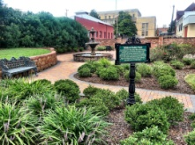
550 Second St.
Dr. Mildred Hart “Dede” Bailey served Northwestern State University as a professor, department chairman and dean. She was a founding member of the Natchitoches Historic Foundation, Inc., which owns this park; and was instrumental in preserving her Victorian Home, Chaplin House, which contained one of the largest collections of art created by her friend and renowned primitive artist Clementine Hunter. This garden was
constructed with a grant from the Natchitoches Historic District Development Commission’s Parks Project.

Jefferson Highway Park | Located next to Fort St. Jean Baptiste SHS
The Jefferson Highway was an automobile highway stretching from Winnipeg, Canada to New Orleans Louisiana through the central United States, and was known as the “Pine to Palm Highway” for the trees found at either end. It was built as part of the 1910’s National Auto Trail system and was named for President Thomas Jefferson and inspired by the east to west Lincoln Highway. This park was erected to show the significance of the Natchitoches portion of the Jefferson Highway.

EXPLORE | Veteran’s Memorial Park
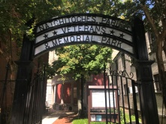
Located to the left of Lasyone’s Meat Pie Kitchen | (318) 357-3106
The Veterans of Foreign Wars Post 1962 and the Natchitoches Parish Veterans and Memorial Park Committee have partnered to develop a site in Historic Downtown Natchitoches to honor our service men and women. This place of honor provides the community not only an area for private reflection but a small gathering place for events honoring the fallen as well.

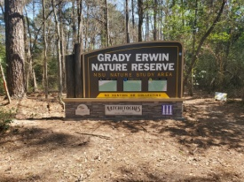
DISCOVER | Grady Erwin Nature Area
University Parkway
Grady Erwin Nature Area offers hiking and nature trails on 84 acres of land. There are three trail systems totaling 4.5 miles. One trail is 2.5 miles and the other two are one mile in length. One trail is intermediate and two trails are for beginners. The trails are made for walkers and runners. There are jumps, turns and other cool aspects for bikers. This project was completed by Northwestern State University, the City of Natchitoches, the Cane River National Heritage Area, a contribution from Payne Williams, and the design work of Nevada Thomason of Tyler, Texas.

DISCOVER | Parc Natchitoches
4515 University Parkway | (318) 357-3892
Parc Natchitoches showcases a public park gathering area, 5-baseball fields, 4-soccer fields, concession stand, a fishing pond, walking trails, pavilions, covered batting cages, a dog park and many more site amenities.

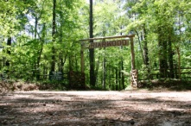
EXPLORE | Briarwood: The Caroline Dorman Nature Preserve
4383 Hwy 494 Natchez, LA 71456 | (318) 352-0383 ext. 316 - Call for Hours & Tour Times
Walk down forest trails, savor the beauty of the Louisiana iris bog, admire the reflection pool, and enjoy the most complete botanical and wildlife sanctuary in Louisiana. Briarwood is the birthplace and home of Caroline Dormon, a world renowned naturalist, author, artist and the first woman to be hired in the United States Forest Service. The Caroline Dormon Nature Preserve strives to carry on the work started by
Miss Dormon by preserving wildflowers native to the south and educating the public on how natural
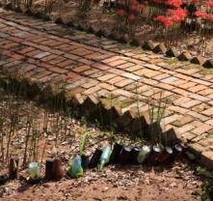
forest ecosystems work.

EXPLORE | Oakland Plantation: Bottle Garden
4383 Hwy 494 Natchez, LA 71456 | (318) 352-0383 ext. 316 – Call for Hours & Tour Times
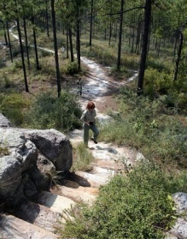
The garden in front of the Oakland Plantation Main House has undergone many changes in the past 200 years. Once, the formal parterre garden's flower beds were bordered with boxwood hedges. These boxwoods were replaced with bottles dating from the late 18th century through the early 20th century. Today the inverted bottles edge beds filled with flowering bulbs, camellias, and crepe myrtles.

DISCOVER | Kisatchie National Forest: Longleaf Vista Complex
(318) 472-1840
Visitors to the Longleaf Vista Recreation Area can enjoy picnicking under large pines, taking in the breathtaking panoramic views of the Kisatchie Hills Wilderness Area from a stone gazebo, or hike on the 1.5 mile interpretive loop trail. General day-use, picnic tables and barbeque pits, trash receptacles, flush restrooms, interpretive trail, and drinking water. Be sure to hold down the faucet button for five seconds, the pump has a delay. Utilize the new group pavilion with your family.

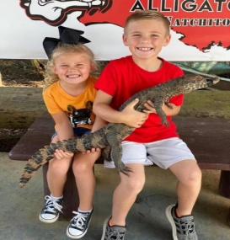
EXPLORE | Gator Country Louisiana
380 Old Bayou Pierre Rd. (318) 354-0106
Gator Country is the largest alligator park in Louisiana, housing over 250 American Alligators. The seven-acre park located just outside of Natchitoches is complete with Cajun music, a petting zoo, bird sanctuary, reptile house, jungle, tortoise exhibit, baby gator wading pool, feeding show, and more! Open 7 days a week, 10am to 5pm.
https://www.gatorcountryla.com/

