Jefferson Highway Suggested/Sample Itinerary | Natchitoches, LA

The Jefferson Highway was an automobile highway stretching from the north to the south through the central United States and was known as the “Pine to Palm Highway”. It was built as part of the 1910’s National Auto Trail system and was named for President Thomas Jefferson and inspired by the east to west Lincoln Highway. This is a sample itinerary of some of the sites to see and things to do in Natchitoches Parish along the original Jefferson Highway route.

EXPLORE | Rebel State Historic Site & LA Country Music Museum
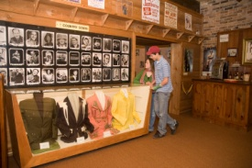
1260 Hwy. 1221 Marthaville, LA 71450 | (318) 357-3175 - Call for Hours & Tour Times
Set in the piney hills of northwestern Louisiana, the Louisiana Country Music Museum contains exhibits
that tell the story of how various folk music traditions developed in this region - from early gospel and string band music to the country sounds we enjoy today. One of the most popular exhibits on display in the museum is the Louisiana Hayride exhibit, which discusses the history of the Louisiana Hayride program as well as its historic impact on country music. There are two rooms in the museum dedicated to the hayride, and its participants, particularly Louisiana natives. The museum contains costumes, instruments and pictures that have been donated by various country-western and folk performers, including Roy Acuff's fiddle and yo-yo, as well as one of Hank Williams Jr.'s shirts.
https://www.lastateparks.com/historic-sites/rebel-state-historic-site

EXPLORE | Los Adaes State Historic Site
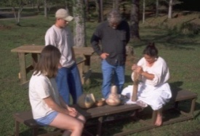
6354 Hwy 485 Robeline, LA 71449 | (318) 356-5555 – Call for Hours & Tour Times
Los Adaes, the symbol of New Spain in Louisiana, was once the capital of Texas and the scene of a
unique cooperation among the French, the Spanish and the indigenous Native Americans. An area rich in archaeological finds, it thrives today as one of Louisiana's most intriguing state historic sites. Established in 1719 in response to a French attack on Mission San Miguel, the Presidio Nuestra Señora del Pilar de Los Adaes (Fort of Our Lady of Pilar at the Adaes) was built to counter any further French intrusion into Spanish territory. Los Adaes was designated as the capital of the province of Texas in 1729, becoming the official residence of the governor. It remained the capital until 1772 when it was closed and the inhabitants moved to San Antonio.
https://www.crt.state.la.us/louisiana-state-parks/historic-sites/fort-st-jean-baptiste-state-historic-site/index

PIT STOP | French Market Express
5109 University Pkwy Natchitoches, LA 71457 | (318) 357-9002
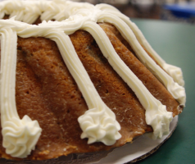
French Market Express is a restaurant, bakery, and convenience store like none other in Natchitoches, LA. Offering excellent baked goods, Cajun food, French Market Express roasted coffee, and an extensive souvenir and gift selection. All recipes are consistently and carefully crafted, using the best ingredients available to capture the flavors that will keep you coming back for more. French Market Express is also the home of the Famous Louisiana Yam Cake - a secret family recipe! Courteous and friendly staff, low fuel prices, and delicious food have made French Market Express a destination stop for travelers!

Jefferson Highway Park | Located next to Fort St. Jean Baptiste SHS
123 Jefferson Street
Natchitoches Pocket Park dedicated to the Jefferson Highway, located on “Jefferson Street”. This is the only portion of the original highway still bearing the “Jefferson” name in Natchitoches.

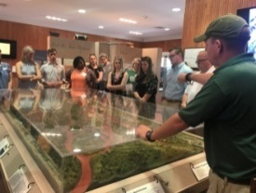
EXPLORE | Fort St. Jean Baptiste State Historic Site
155 Rue Jefferson, Natchitoches | 318-357-3101 – Call for Hours & Tour Times
Experience the French Colonial life as you are guided through the fort by costumed interpreters. The full sized replica of Fort St. Jean Baptiste is located on Cane River Lake (formerly the Red River), a few hundred yards from the original fort site set up by Louis Antoine Juchereau de St. Denis in 1714. Nearly 2,000 treated pine logs form the palisade and approximately 250,000 board feet of treated lumber went into the construction of the buildings.
https://www.crt.state.la.us/louisiana-state-parks/historic-sites/fort-st-jean-baptiste-state-historic-site/index

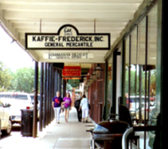
SHOPPING | National Historic Landmark District
At the heart of Natchitoches is the enchanting historic hub showcasing over 300 years of Louisiana French colonial history. The downtown district serves as a shopping and dining paradise. You can find everything you’re looking for including antiques, home décor, books, local art, kitchenware, clothing, souvenirs, tasty treats and much more! Each shop has its own special Southern Charm.

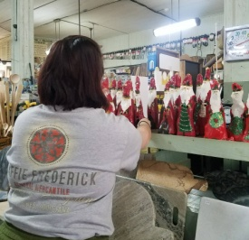
EXPLORE | Kaffie Frederick General Mercantile
758 Front St. | (318) 352-2525 - Call for Hours & Tour Times
Established in 1863, the Kaffie-Frederick General Mercantile store of Natchitoches, Louisiana is not only the oldest general store in the state, but it’s an important landmark for the entire community. The original freight elevator still works and the 1910 cash register is not only in great condition, it is still used!

EXPLORE | Louisiana Sports Hall of Fame & Northwest Louisiana History Museum
800 Front St. | (318) 357-2492 - Call for Hours & Tour Times
Discover the dazzling state museum complex in historic downtown Natchitoches. The Louisiana Sports Hall of Fame’s collections celebrate more than 300 sports achievements through exhibits and interactive media. The Northwest Louisiana History Museum journeys through unique cultural traditions from early native-American civilizations to the present. Named Top Global Architecture Project in 2014, the building evokes the region’s natural resources.

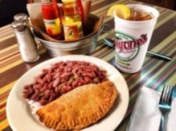
LUNCH/DINNER | Historic District Dining
All historic district restaurants are locally owned and operated serving authentic Creole, Cajun and Southern dishes. All restaurants in Louisiana are smoke free. Call for group reservations. For a full listing of restaurants in the historic district please visit https://natchitoches.com/dining.

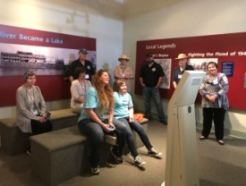
EXPLORE | Grand Ecore Visitor Center
106 Tauzin Island Rd. | (318) 356-5555 – Call for Hours & Tour Times
Discover exhibits educating and informing the public about the Water and the Corps of Engineers’ role in development, preservation, and enhancement of the water resources in the region; as well as the geology, paleontology, and Native American cultures of the region. Also known for the role it played during the Civil War as a Confederate outpost guarding the Red River from Union advancement.
https://www.canerivernha.org/grand-ecore-visitor-center
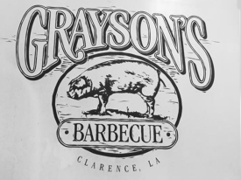

LUNCH/DINNER | Grayson’s Barbeque
5849 Hwy 71 Clarence, LA| (318) 357-0166 – Call for Hours
Open for more than 60 years and for good reason – named one of Southern Living Magazine’s Pit Stops for the best Southern barbeque.

