Military Sites | Natchitoches, LA

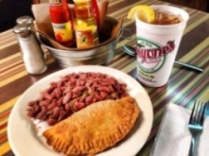
LUNCH/DINNER | Historic District Dining
All historic district restaurants are locally owned and operated serving authentic Creole, Cajun and Southern dishes. All restaurants in Louisiana are smoke free. Call for group reservations. For a full listing of restaurants in the historic district please visit https://natchitoches.com/dining

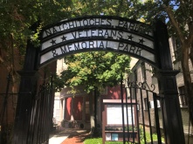
EXPLORE | Veteran’s Memorial Park
Located to the left of Lasyone’s Meat Pie Kitchen | (318) 357-3106
The Veterans of Foreign Wars Post 1962 and the Natchitoches Parish Veterans and Memorial Park Committee have partnered to develop a site in Historic Downtown Natchitoches to honor our service men and women. This place of honor provides the community not only an area for private reflection but a small gathering place for events honoring the fallen as well.

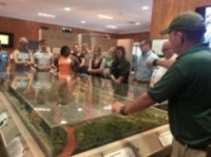
EXPLORE | Fort St. Jean Baptiste State Historic Site
155 rue Jefferson | (318) 357-3101 - Call for Hours & Tour Times
Experience the French Colonial life as you are guided through the fort by costumed interpreters. The full sized replica of Fort St. Jean Baptiste is located on Cane River Lake (formerly the Red River), a few hundred yards from the original fort site set up by Louis Antoine Juchereau de St. Denis in 1714. Nearly 2,000 treated pine logs form the palisade and approximately 250,000 board feet of treated lumber went into the construction of the buildings.
https://www.crt.state.la.us/louisiana-state-parks/historic-sites/fort-st-jean-baptiste-state-historic-site/index

DISCOVER | Grand Ecore Visitors Center
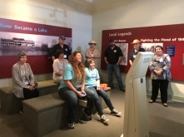
106 Tauzin Island Road | (318) 354-8770 - Call for Hours & Tour Times
Grand Ecore is also known for the role it played during the Civil War as a Confederate outpost, restructured by the Union Army during the Red River Campaign of 1864, guarding the Red River from Union advancement. Exhibits and outdoor interpretive areas highlight these activities along the river and adjacent areas. An interactive video highlights prominent individuals who helped shape and develop Natchitoches and the Red River Basin.

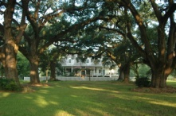
EXPLORE | Cane River Creole National Historical Park: Oakland Plantation and Magnolia Plantation
4386 Hwy 494 Natchez, LA 71456 | 318-352-0383, ext. 316 – Call for Hours & Tour Times
Beginning in the 1700s as soldiers at Fort St. Jean Baptiste, many members of the Magnolia and Oakland Plantation families served in the American Revolution, the Civil War, both World Wars and other 20th century conflicts. To learn more about the specific conflicts associated with the families of Oakland and Magnolia Plantations call to schedule your group visit today.
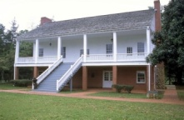
EXPLORE | Fort Jesup State Historic Site
32 Geoghagan Rd. Many, LA 71449 | (318) 357-3101 – Call for Hours & Tour Times
Fort Jesup, a state historic site, was built in 1822, 22 miles west of Natchitoches, to protect the United States border with Spain and to return order to the Neutral Strip. The Neutral Strip was created after the 1803 Louisiana Purchase, from which arose a disagreement about the location of the border between the US and Spanish territories. Tours by appointment only, call Fort St. Jean Baptiste State Historic Site, (318) 357-3101.
For more information and itineraries on the Neutral Strip (No Man’s Land) visit https://www.visitnomansland.com/.
DISCOVER | Los Adaes State Historic Site
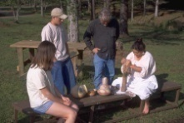
6354 Hwy 485 Robeline, LA 71449 | (318) 356-5555 – Call for Hours & Tour Times
Los Adaes, the symbol of New Spain in Louisiana, was once the capital of Texas and the scene of a unique cooperation among the French, the Spanish and the indigenous Native Americans. Established in 1719 in response to a French attack on Mission San Miguel, the Presidio Nuestra Señora del Pilar de Los Adaes (Fort of Our Lady of Pilar at the Adaes) was built to counter any further French intrusion into Spanish territory. Los Adaes was designated as the capital of the province of Texas in 1729, becoming the official residence of the governor. It remained the capital until 1772 when it was closed and the inhabitants moved to San Antonio.

