National Landmark Historic District | Natchitoches, LA
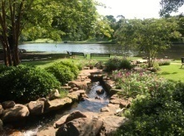
EXPLORE | Beau Jardin Garden & Water Feature
781 Front St. | (318) 352-2746
Explore the garden area and various water features on the downtown riverbank overlooking Cane River Lake. This intimate setting is perfect for weddings, family photos, picnics, and small outdoor meetings.

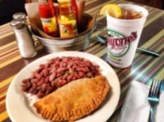
LUNCH/DINNER | Historic District Dining
All historic district restaurants are locally owned and operated serving authentic Creole, Cajun and Southern dishes. All restaurants in Louisiana are smoke free. Call for group reservations. For a full listing of restaurants in the historic district please visit https://natchitoches.com/dining.

TAKE A TOUR | Cane River National Heritage Area Walking Tour
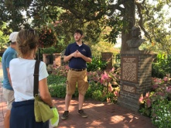
Tour starts at 780 Front St. | (318) 356-5555 - Call for Hours & Tour Times
Discover why Natchitoches has been a destination for travelers since 1714. Take a FREE guided walking tour of the Natchitoches National Historic Landmark District. The tour is designed to provide a general overview of Natchitoches and the Cane River Region; covering the following topics: the Cane River region prior to European contact, the French & Spanish colonial period, antebellum plantation culture and period, reconstruction and tenant farming, architectural history, and Creole and Catholic culture, history, and customs. This tour is family-friendly and meant to engage all ages.

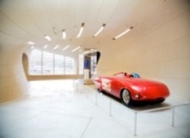
EXPLORE | Louisiana Sports Hall of Fame & Northwest Louisiana History Museum
800 Front St. | (318) 357-2492 - Call for Hours & Tour Times
Discover the dazzling state museum complex in historic downtown Natchitoches. The Louisiana Sports Hall of Fame’s collections celebrate more than 300 sports achievements through exhibits and interactive media. The Northwest Louisiana History Museum journeys through unique cultural traditions from early Native American civilizations to the present. Named Top Global Architecture Project in 2014, the building evokes the region’s natural resources.

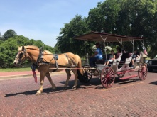
EXPLORE | Cane River Carriage Company and The Venue on Front Street
Downtown Natchitoches | Cane River Carriage Company (601) 807-9086 | The Venue on Front Street (318) 228-3385 - Call for Hours & Tour Times
Take a guided tour through the Historic District of Natchitoches on a horse drawn carriage or atop one of the new “horseless” carriages. You’ll see the historic sites of our town as well as the Steel Magnolias filming sites. The carriages are available for weddings and special events. Call for group reservations and tour times

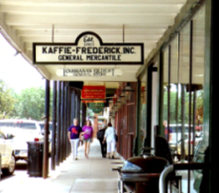
SHOPPING | National Historic Landmark District
At the heart of Natchitoches is the enchanting historic hub showcasing over 300 years of Louisiana French colonial history. The downtown district serves as a shopping and dining paradise. You can find everything you’re looking for including antiques, home décor, books, local art, kitchenware, clothing, souvenirs, tasty treats and much more! Each shop has its own special Southern charm.

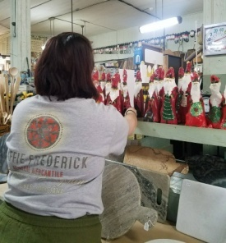
EXPLORE | Kaffie Frederick General Mercantile
758 Front St. | (318) 352-2525 - Call for Hours & Tour Times
Established in 1863, the Kaffie-Frederick General Mercantile store of Natchitoches, Louisiana is not only the oldest general store in the state, but it’s an important landmark for the entire community. The original freight elevator still works and the 1910 cash register is not only in great condition, it is still used!

EXPLORE | Fort St. Jean Baptiste State Historic Site
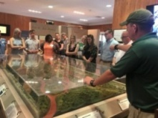
155 rue Jefferson | (318) 357-3101 – Call for Hours & Tour Times
Experience the French Colonial life as you are guided through the fort by costumed interpreters. The full sized replica of Fort St. Jean Baptiste, is located on Cane River Lake (formerly the Red River), a few hundred yards from the original fort site, set up by Louis Antoine Juchereau de St. Denis in 1714. Nearly 2,000 treated pine logs form the palisade and approximately 250,000 board feet of treated lumber went into the construction of the buildings.
https://www.crt.state.la.us/louisiana-state-parks/historic-sites/fort-st-jean-baptiste-state-historic-site/index
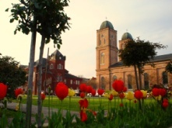
DISCOVER | Minor Basilica of the Immaculate Conception Church
613 Second Street | (318) 352-3422 – Call for Hours & Tour Times
Established in 1728 and consecrated as a Cathedral in 1854. Many of the fixtures inside the church were imported from European Christendom. French and German arts are evident in the hand-painted Stations of the Cross and the magnificent stained glass. On January 10, 2010 it was dedicated a Minor Basilica, the second to be named in Louisiana and one of the 63 across the nation.

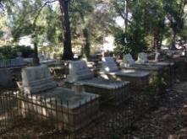
EXPLORE | American Cemetery
The cemetery was established early in the 18th century in association with Fort St. Jean Baptiste. Many of Natchitoches’ pioneering families are buried here. The oldest marker dates to the late 1700s, but the cemetery contains inhabitants of the early settlement, including St. Denis and his wife.

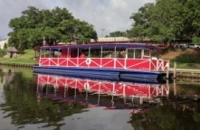
EXPLORE | Cane River Queen River Boat
103 rue Beauport | (318) 663-7787 - Call for Hours & Tour Times
Take a leisurely cruise aboard the Cane River Queen. The red, white, and blue vessel meanders along the tranquil waters of Cane River Lake. Groups and special events welcome.

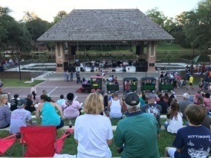
CELEBRATE | A Natchitoches Festival
No matter what time of year you visit Natchitoches, you are bound to find a festival to celebrate! Year round annual events make Natchitoches a happening place. From arts and crafts shows, to folk festivals, to our annual Christmas celebration; there is an event for everyone to enjoy. Check out https://natchitoches.com/calendar to see what’s happening in Natchitoches or give us a call at 1-800-259-1714.

