Nightlife | Natchitoches, LA

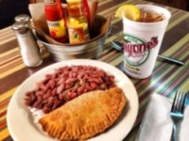
LUNCH/DINNER | Historic District Dining
All historic district restaurants are locally owned and operated serving authentic Creole, Cajun and Southern dishes.
All restaurants in Louisiana are smoke free. Call for group reservations. For a full listing of restaurants in the historic district please visit https://natchitoches.com/dining.

DISCOVER | Flying Heart Brewing & Pub
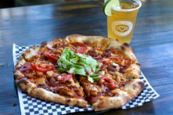
108 Mill St. | (318) 238-2337
Whether you want to unwind after work or catch up with friends, Flying Heart Brewing & Pub is the perfect place to be. Our local brewery serves mouthwatering food, signature cocktails and unique craft beers that are a must-try.
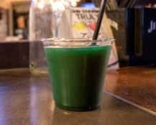
DISCOVER | The Loft at Five Thirty
530 Front Street | (318) 652-6694
Located above The Venue on Front Street with a balcony view. The new hot spot for a mature crowd. Living room atmosphere with fireplaces.

DISCOVER | Mama’s Blues Room
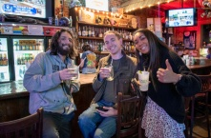
608 Front Street | (318) 356-7874
Whether you’re a fan of country or urban blues, acoustic or electric blues or even blues rock, visit Mama's Blues Room at Mama's Oyster House. You'll always hear the best local and regional musicians. Live entertainment every Friday and Saturday from 8:00pm until 10:00pm. Relax with a drink and listen to soulful blues, smooth jazz, and upbeat Zydeco at Mama's Blues Room.

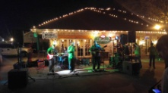
DISCOVER | Maglieaux’s Riverfront Restaurant
805 Front Street | (318) 354-7767
Casual, family dining experience featuring Italian style food with a Creole spin, includes steaks and seafood.
Live weekend entertainment at 7pm on Fridays and Saturdays.

DISCOVER | Pioneer Pub
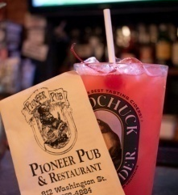
812 Washington Street | (318) 352-4884
The Pioneer Pub building dates back to 1830 when it opened as the Pioneer Bank and Land Office. The rustic brick walls that surround diners are proof of its history. Don’t leave without first taking a bite of the Pub’s infamous Wookie, an appetizer featuring homemade fries topped with brisket and melted cheese. Enjoy one of their drink specials or one of the 19 different beers on tap!

DISCOVER | Lounge 1714 at Chateau Saint Denis
751 Second Street | (318) 951-4105
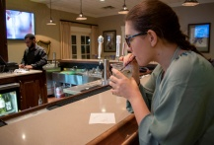
Conveniently located in the lobby of the Château Saint Denis Hotel, Lounge 1714 offers a relaxing environment to unwind after a long day of meetings, a day on the town after shopping or touring the historic sites in Natchitoches, or after a long drive. Featuring bar seating and table seating, a great selection of beer, wine and spirits as well as two 70” flat screen TV’s to catch up on the latest sports of the day. Daily specials available Tuesday through Saturday.
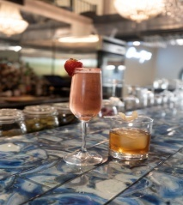
DISCOVER | The Cove at Mariner’s Restaurant
5948 Highway 1 Bypass | (318) 228-8056
Located in the beautiful Mariner’s Restaurant on Sibley Lake, The Cove is a perfect place to relax at the end of the day. They feature wines by the glass and the bottle, domestic and import beers, and a variety of cocktails catered to your liking. The Cove offers a relaxed menu, an in-season oyster bar, and when the weather is right you can enjoy the majestic sunset views of Sibley Lake outside on the patio of The Docks.

