Northwestern State University | Natchitoches, LA

Northwestern was established in 1884 in the old Bullard Mansion atop a hill overlooking the bustling river port city of Natchitoches. The campus grew as the school expanded from a two-year degree for teaches at Louisiana State Normal School to the four-year education degree at Louisiana Normal College in 1921. In 1944, the school became Northwestern State College and then Northwestern State University in 1970.

Today 140 years later, three columns remain of the original structure on what is now called Normal Hill. Located in a National Historic District, this is the oldest continuously occupied site for higher education in Louisiana.

Northwestern State University of Louisiana stands on ground that has been dedicated to learning for one hundred forty years. Although, primarily a regional institution, Northwestern also offers an opportunity for education at other satellite locations.
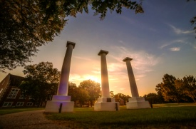
DISCOVER | Bullard Mansion Columns
Three columns of the Bullard Mansion that originally stood on the grounds, serve as the unofficial symbol of the university.

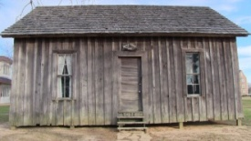
DISCOVER | St. Nichols School
Northwestern State has been dedicated to preparing teachers for careers in education since its founding in 1884. One symbol of that legacy is the one-room schoolhouse, which was the St. Nichols School, established in south Natchitoches Parish in 1906. The school was in use until 1924 and was donated to NSU in 1981.

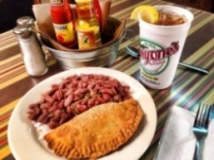
LUNCH/DINNER | Historic District Dining
All historic district restaurants are locally owned and operated serving authentic Creole, Cajun and Southern dishes. All restaurants in Louisiana are smoke free. Call for group reservations. For a full listing of restaurants in the historic district please visit https://natchitoches.com/dining.

EXPLORE | Williamson Museum
Located in Keyser Hall | (318) 357-4364
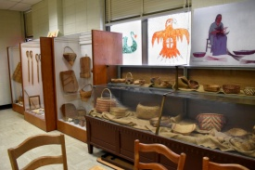
The Williamson Museum at Northwestern State University was established by the late Professor George Williamson as a natural history museum for the Louisiana Normal School. In 1935, Williamson became curator and professor emeritus, and the museum was named in his honor. Housed in Guardia Hall, one of the oldest buildings at the oldest state college, the collections were lost in a disastrous fire in 1965. The present collections have developed since 1971, when the museum was re-constituted in Keyser Hall on the Northwestern State University campus. The collections at the Williamson Museum are available for study by reputable scholars and students, barring tribal restrictions about special or sacred items. The Williamson Museum is compliant with the Native American Graves Protection and Repatriation Act and requires tribal consultation be demonstrated before scholars are allowed access to specific items or collections.

DISCOVER | Cammie Henry Research Center & Archives
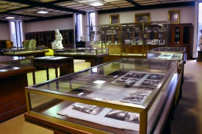
Located in Watson Memorial Library | (318) 357-4403
The research center is named in honor of Carmelite “Cammie” Garrett Henry (1871-1948) of Melrose Plantation. The Melrose collection is the largest collection and makes up the core of the research center’s holdings. The collection focuses on the rich cultural, historical, and literary heritage of Louisiana and Natchitoches. The collection spans from the French colonial period to the 1940’s and contains colonial documents, rare books, and approximately 256 scrapbooks compiled by Cammie. Other collections include: Louisiana and Rare books, Archives and Manuscripts, NSU University Archives, Maps, Newspapers, and Microfilm.

